Suggested solution to assignment 2

Chapter 3
- A social psychologist asked 15 randomly selected college students how many times they “ fell in love” before they were 16 years old . The numbers of times were as follows:
2, 0, 6, 0, 3, 1, 0, 4, 9, 0, 5, 6, 1, 0, 2.
Give the measures of central tendency (mean, median, mode) and variation (range, variance, standard deviation).
Ans:

The measures of central tendency
Mean 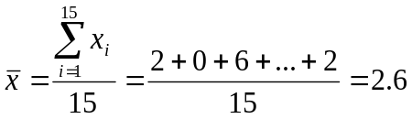
Arrange the numbers in increasing order as follows:
0, 0, 0, 0, 0, 1, 1, 2, 2, 3, 4, 5, 6, 6, 9
We can get the middlemost value median is 2.
Mode=0 as 0 appears most frequently.
Range=9-0=9
Sample variance 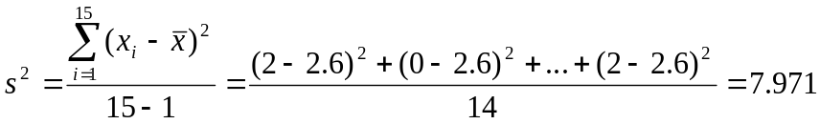
Sample standard deviation 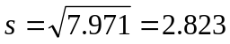

2. Thirteen internists in the Midwest are randomly selected, and each internist is asked to report last year’s income. The incomes obtained (in thousands of dollars) are 152, 144, 162,154, 146, 241, 127, 141, 171, 177, 138, 132, 192. Find:
  - The 90th percentile.
  - The median.
  - The first quartile.
  - The third quartile
  - The 10th percentile.
  - The inter-quartile range.
  - Develop a five-number summary and a box-and-whiskers display.
Answer: There are 13 measurements in total (n=13). First, arrange the measurements in increasing order:
127 | 132 | 138 | 141 | 144 | 146 | 152 | 154 | 162 | 171 | 177 | 192 | 241

- The 90th percentile.
Calculate the index of the 90th percentile: 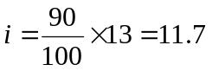
Round 11.7 up to 12, hence the 90th percentile is the 90th measurement 192.

- The median.
The median is equivalent to the 50th percentile: 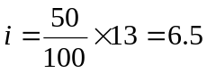
Round 6.5 up to 7, hence the median is the 7th measurement 152.

- The first quartile.
We know the index of the first quartile can be found as: 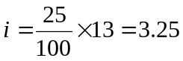
Round 3.25 up to 4, hence the first quartile is the 4th measurement 141.

- The third quartile
We know the index of the third quartile can be found as: 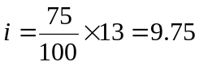
Round 9.75 up to 10, hence the third quartile is the 10th measurement 171.

- The 10th percentile.
Calculate the index of the 10th percentile: 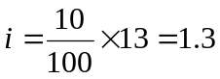
Round 1.3 up to 2, hence the 10th percentile is the 2nd measurement 132.

- The interquartile range.
Interquartile range is the difference between first and third quartile
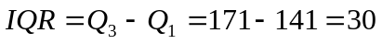
- Develop a five-number summary and a box-and-whiskers display.
Five number summary: min=127,first quartile=141,median=152,third quartile=171,max=241
Box-plot:
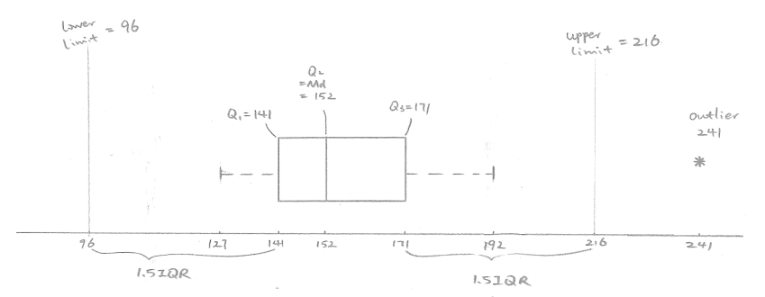
3. As given on the Morningstar website, the mean return for Fidelity Leveraged Company Stock is 17.98 percent with a standard deviation of 10.02 percent, while the mean return for Baron Opportunity Retail Stock is 16.43 percent with a standard deviation of 12.23 percent. Which stock is riskier than the other one?
Ans:
The mean return for Fidelity Leveraged Company Stock is higher than of Baron Opportunity Retail Stock.
When we compute and compare the coefficient of variation for these two stocks using 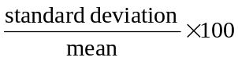 , we find that the coefficient of variation of Fidelity Leverage (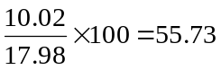) is lower than the one of Baron Opportunity (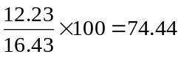), meaning the variation in returns for the Baron Opportunity is higher, so investing in Baron Opportunity is riskier.

4. The Rivertown city council is attempting to choose one of four sites (A, B, C, or D) as the location for its new emergency facility. After the new emergency facility becomes available for service, the current emergency facility will be shut down. The project manager has estimated the following response times in minutes from each of the proposed sites to the four areas that must be served by the emergency facility.
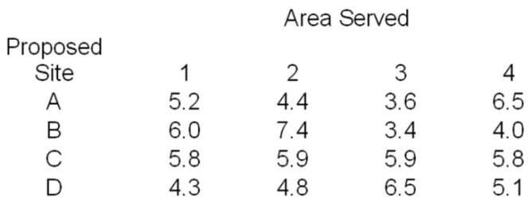
The number of emergency runs from the current emergency facility to each of the four areas over the past year is as follows:
Compute the weighted mean response time from the proposed locations and determine which proposed site should be selected for the new emergency facility.
Answer: The response times in minutes for site A are 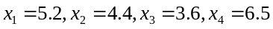, and the weights applied to these measurements are 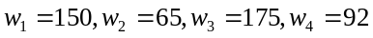.
That is, we are weighting the response times by the number of emergency runs. The weighted mean is computed as follows:
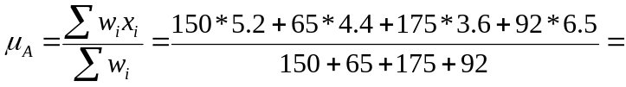4.76
Similarly,
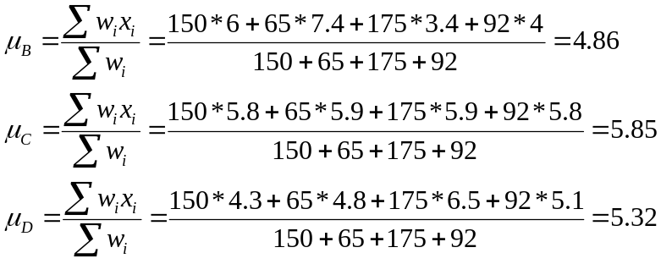
Since the weighted mean response time from location A is the smallest, site A should be selected for the new emergency facility.

5. Compare the population mean, median, and mode when the shape of distribution of the population is
a. Symmetrical
b. Skewed to the left
c. Skewed to the right

Ans: a. Equal
b. The population mean is smaller than the population median, and the population median is smaller than the population mode.
c. The population mean is larger than the population median, and the population median is larger than the population mode.

6. TOFEL and GMAT examinations are held in UIC. Suppose the scores for these two English tests are both normally distributed, the TOFEL results have a mean of 90 and a standard deviation of 15 while scores on the GMAT test have a mean of 750 and a standard deviation of 25. Which is relatively better: a score of 105 on the TOFEL test or a score of 800 on the GMAT test? Why? (Hint: z-score)
The z-score of 105 mark in TOFEL test is 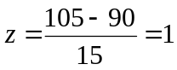 .
The z-score of 800 mark in GMAR test is 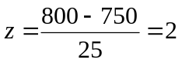
Both z-score is positive, while the z-score of 800 in GMAT is larger, which means this performance is twice the standard deviation of the mean performance. It is therefore more difficult to achieve 800 in GMAT than getting 105 in TOFEL.

